## **Exhaustive Analysis of Indian Agriculture**

We will analyze 19 years of Indian Agriculture data to find various parameters of crop production , prediction based on past data and Minimum support price for the given crop for the given year. Here the main aim is to create a dashboard.

**Session – 1**

In this session I understood about

* The basics of data analytics, power bi and related concepts
* Data analytics case study on Indian agriculture sector

**BI:** Business intelligence represents the technical infrastructure that collects, stores, and analyzes company data. BI translates raw data into actionable insights, providing managers with reports and information to make informed business decisions.

**Power BI:** It is a BI tool and product of Microsoft. Power BI is a collection of software services, apps, and connectors that work together to turn various sources of data into static and interactive data visualizations.

**ETL :** It is the process of Power BI.

**E –> Extract:** It is used to pull the data from the data source. The data source can be a excel, csv, text, database files and that can be n number of data sources which we can pull the data.

**T –>Transform**: The data may have some mistakes, so we perform data transformation is used to clean the data and process the data. That includes remove the duplicates and removing unknown values and unnecessary rows / columns.

**L –> Load:** loading the clean and transformed data for analysis.

Analysis is nothing but we keep all the facts, insights via dashboard, so we are creating the dashboard for the Indian agriculture.

For this we have to download the **POWER BI DESKTOP** which is available in the Microsoft store.

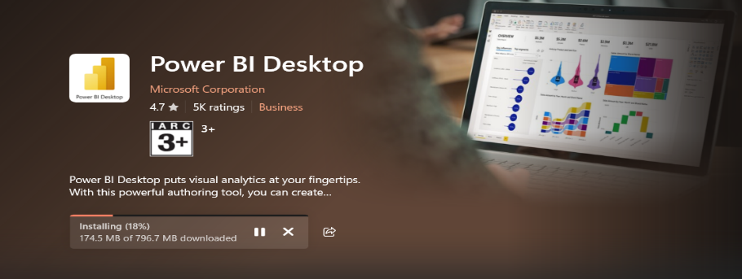

After Installation we have to open the application, after opening the app it may look like this

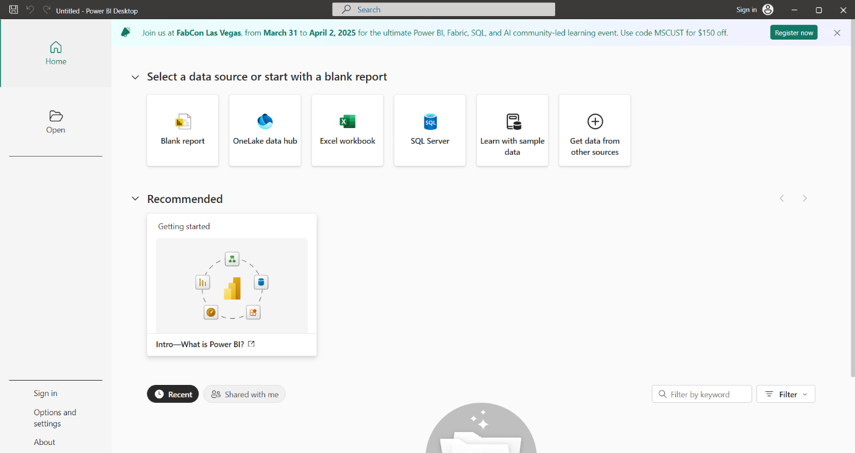

And this is the welcome window of the power bi.

Now we have to click on the Blank report, which is present in the welcome window of Power Bi .

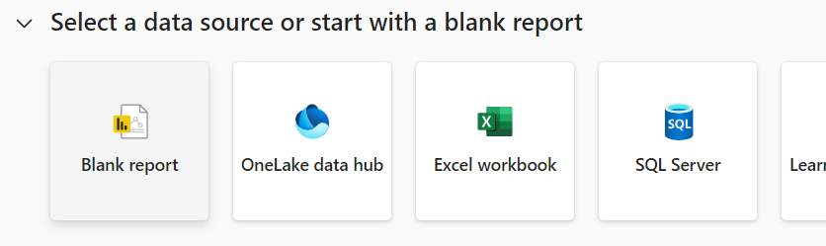

When we click on the blank report we will enter into the power BI Desktop.

The window open like this,

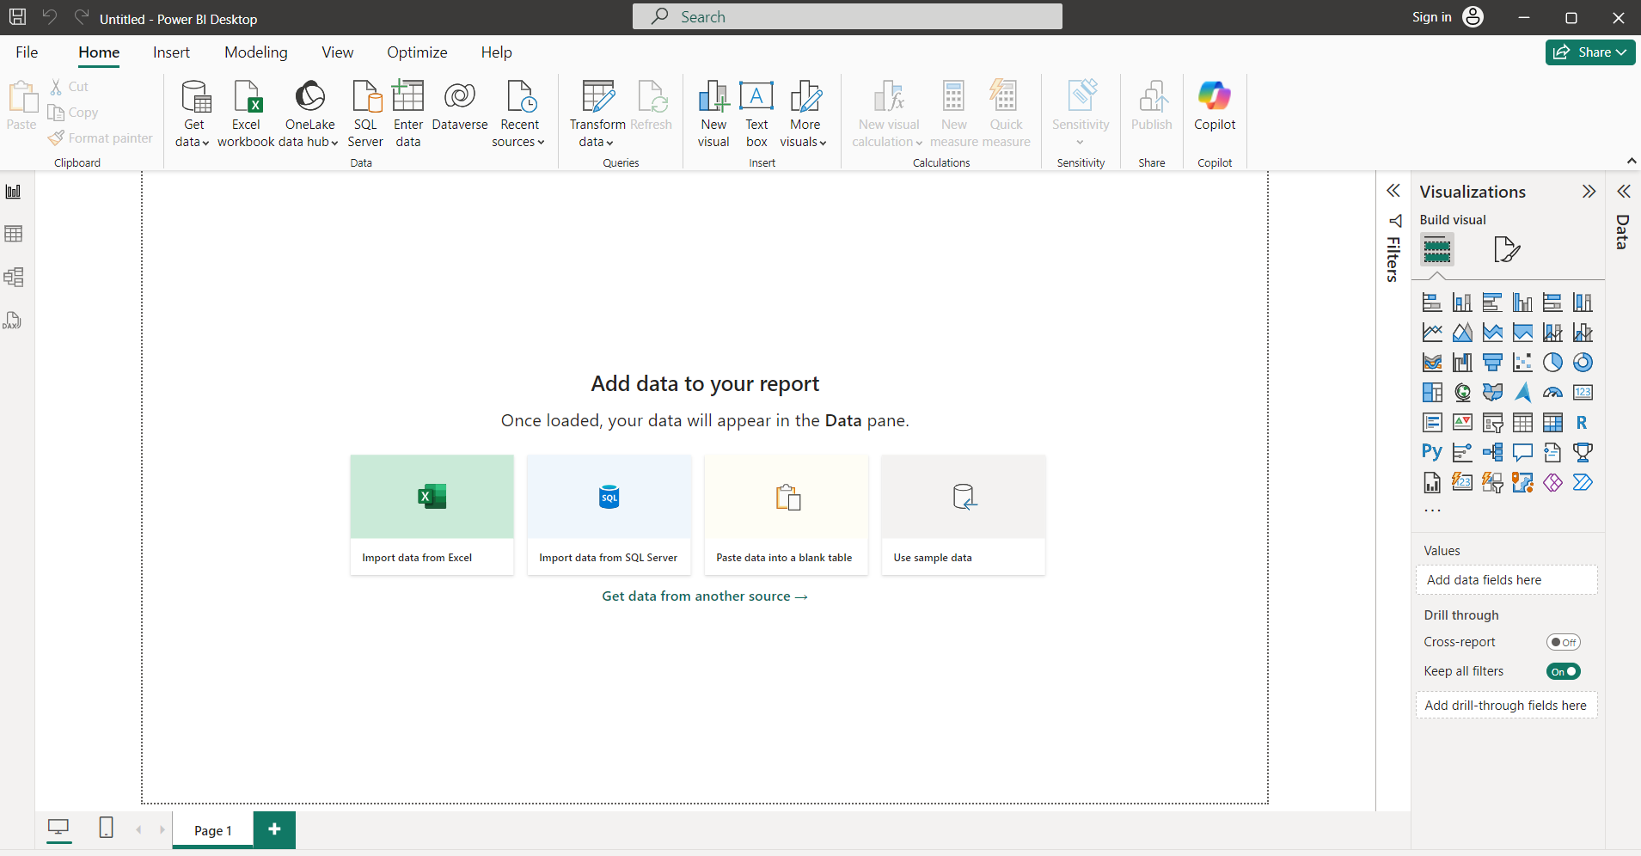

We have multiple features in this window such as Visualizations which is used to draw certain graphs , filters , and multiple tabs that are file , home , insert, modelling etc.

As of know we are using the Home Tab only.

If we want to Extract the data we will be using the data set which is provided.

By using the **Get data** button, we can get the data which we called as data sources.

We extract the data from the data sources only.

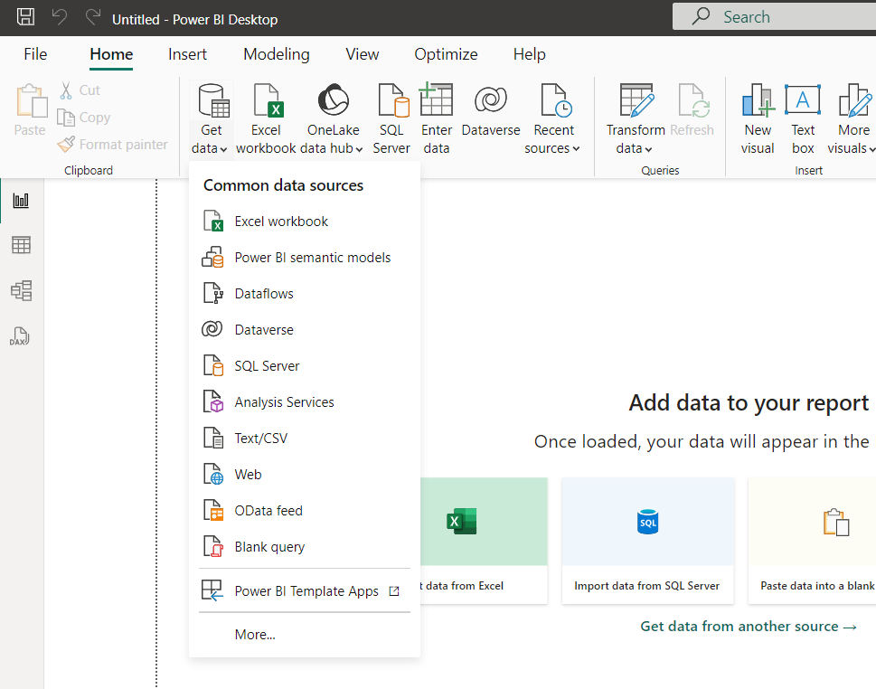

We can select the data source by using the get data button in the power bi desktop.

After selecting and opening a file the new window will be opened like this.

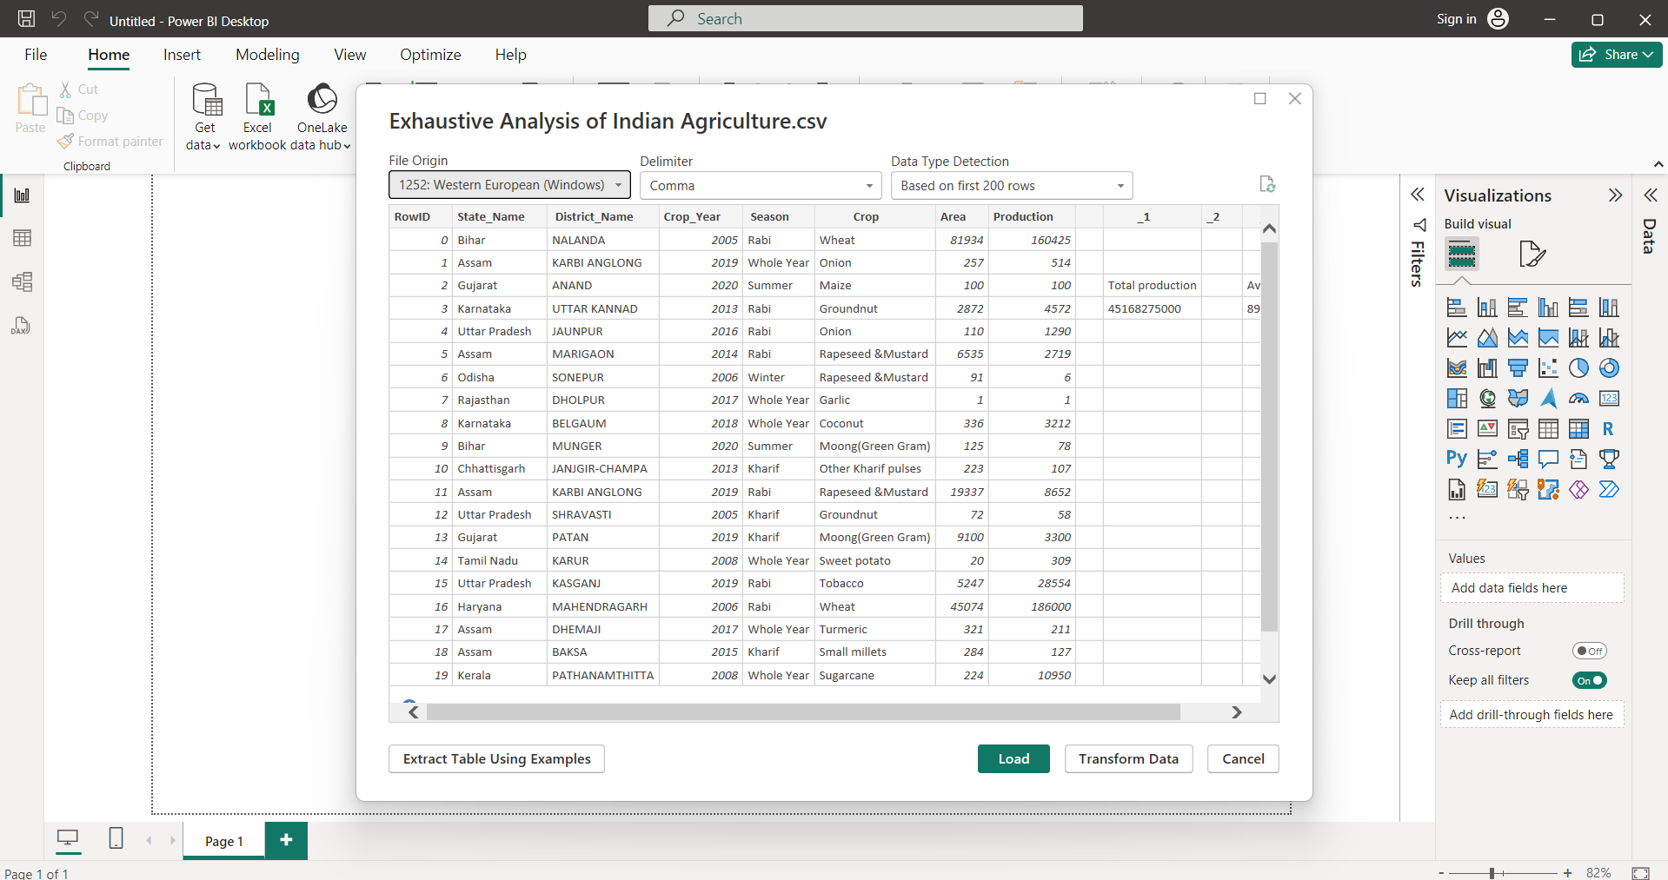

The new opened window is the overview of the data which we are dealing with.

In this window we have mainly 3 buttons

1.Load: We click on the load when the data is clean.

2.Transform: We click on the transform when we want to process the data.

3.Cancel: To cancel the data.

Even my data is not clean, when I click the load button it may display like this. In the right hand side the file has been added like this.

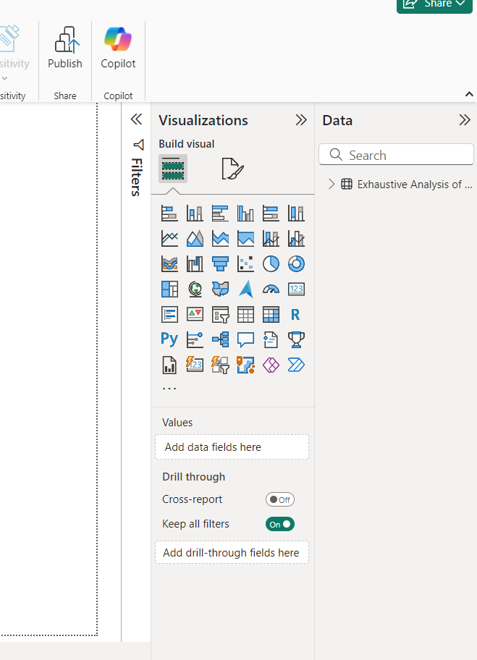

In the left hand side we have 3 views that look like this.

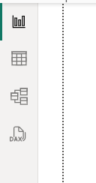

1.**Report View:** we perform all the visualization

2.**Table view:** we can see the data which we are dealing

3.**Model view:** For creating the relationship among the data.

Now we have completed the data Loading. And now we have to Transform the Data.

We Transform the data with help of the button in the Home tab, which we known as Transform data. If we pull the data we need to transform.

Click on the Transform data button the new window will appeared like this.

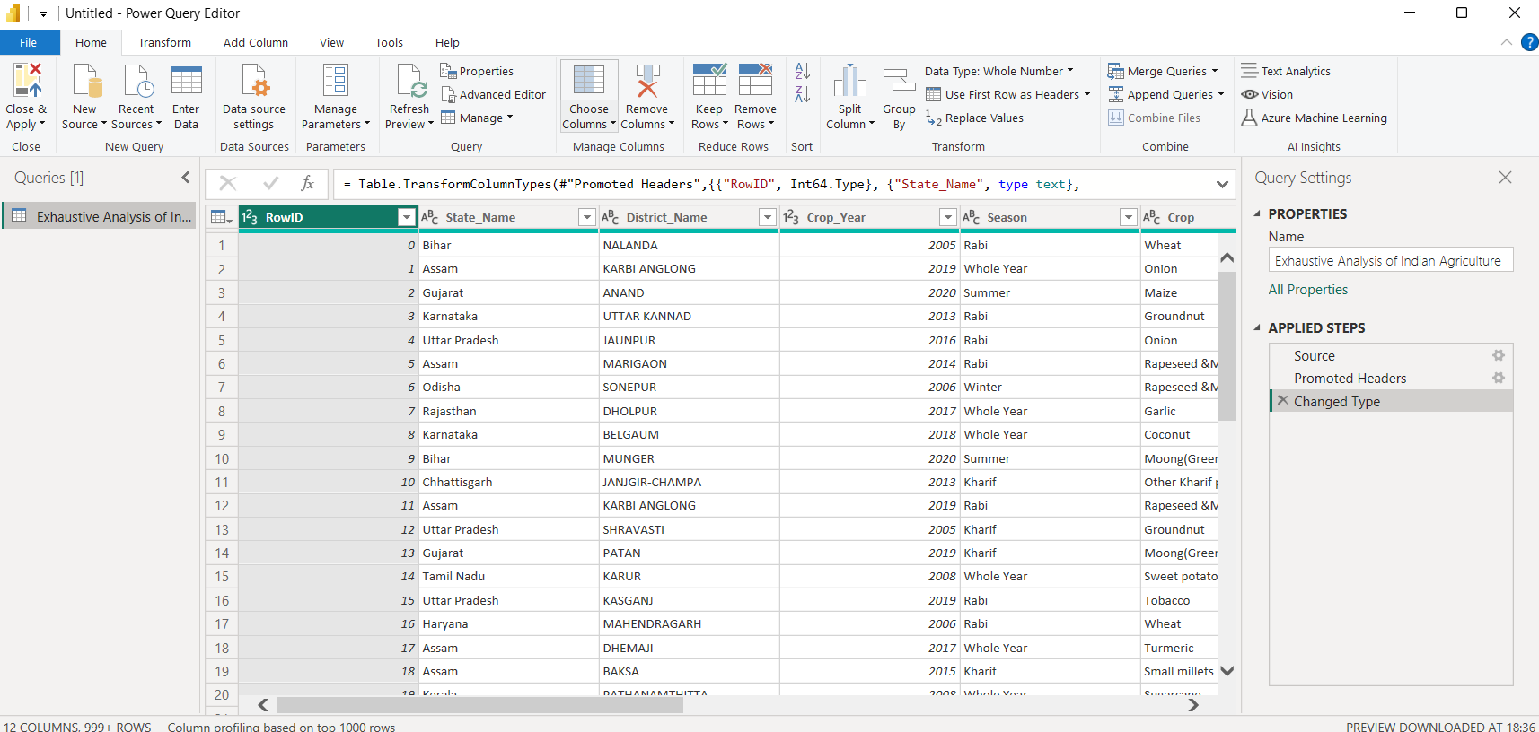

This window is the heart of the any analysis because we can do all the cleaning process with the help of the window. This window is nothing but the **POWER QUERY EDITOR**. We can do all the transformation with the help of this particular window.

As you can see there will be the 2 windows running over there. The one is **Power Bi Desktop** and the other is **Power Query Editor**.

We can have multiple options to transform the data. We don’t need any kind of code for any kind of transformation.

We can see all the columns in the window of our data set.

There may be some blank columns which are not used or helpful for the data analysis. So we can remove or delete the unnecessary column. We remove the column by clicking or select on the column name and right click over there we can see the remove button and then remove the column by clicking the remove button.

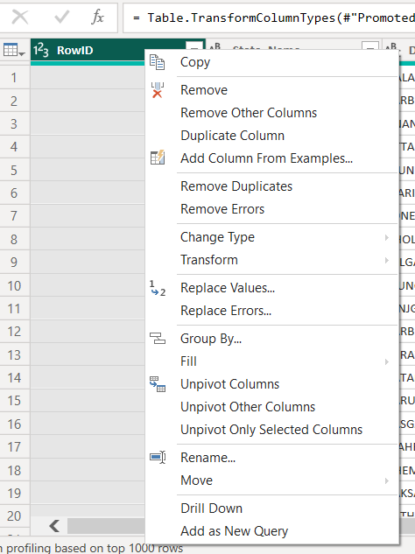

After removing the column we can see the removed column in the Applied Step which is present in the right side.

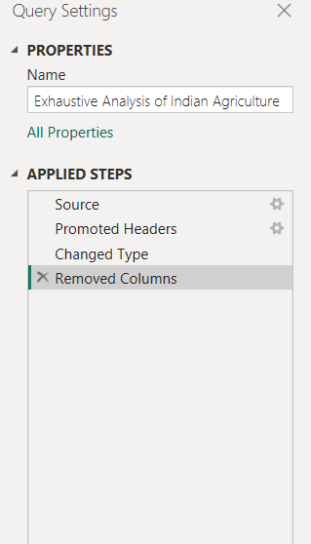

If we want the column back we can get the column by clicking the into button over there beside the removed columns.

And like this we can remove the unwanted or useless columns for the data analysis.

If we want to check whether the data contain null values or not. We do this with the help of view tab. In the view tab we can see the Column quality option, when we do check mark by clicking in the check box we can get the data like this for the every column.

One small box will appear below the column name.

We can get Empty i.e., we don’t have any null values. The Error is like the data type mistake or any kind of error may happened when we load the data.

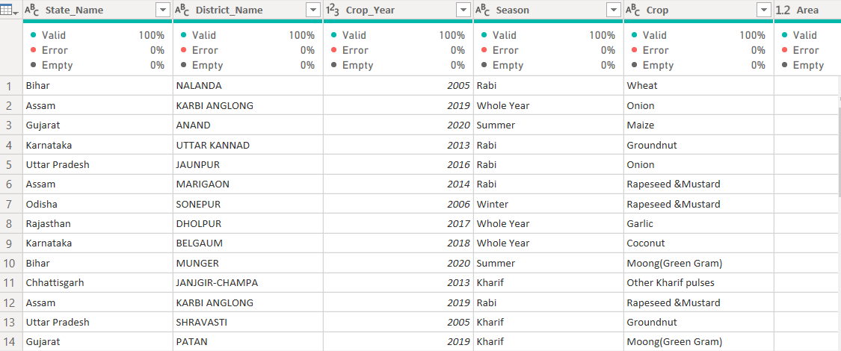

If we have any null values or duplicates we can remove those in the Home tab with the help of Remove row button. If we click the remove row it appear some options like this.

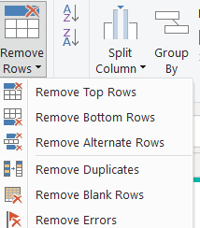

So with the help of this options we can remove errors if any.

As of know we completed the removing, it cannot reflect on the Power BI Desktop from the Power Query Editor. So we have to Apply the changes to the Power Bi Desktop by clickingon the Close and apply button on the left top , it appear like this.

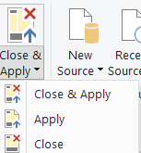

We have to click on the close and apply.

If we want to explore that data, we should click on the table view to view the data. It was viewed without any unnecessary columns in the data set.

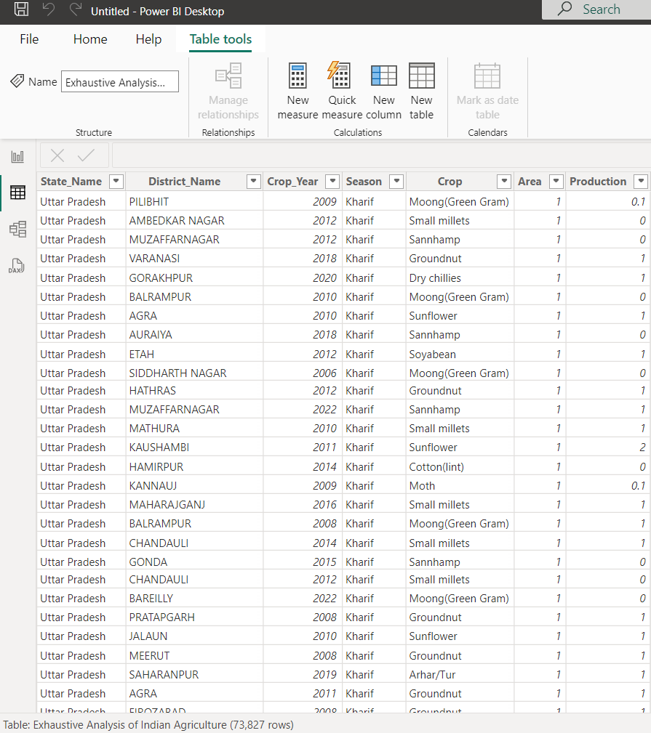

This is the Transformed data.